

**China Economy Monthly Note October 2015**

**Summary – Almost Quiet on the Eastern Front**

June, July, and August were dominated by jitters over China’s economy. September wasn’t wonderful, but there was no crisis. The stock market was down by (only) 4.8% - reflective of the wider ongoing slowdown, but no meltdown. Ongoing debate about whether China’s landing will be soft or hard and no conclusive data. The reputation of China’s leadership as technocrats who can bend the economy and markets to its will took a beating this summer. The spring in President Xi’s step will be a bit less springy when he visits the UK next week.

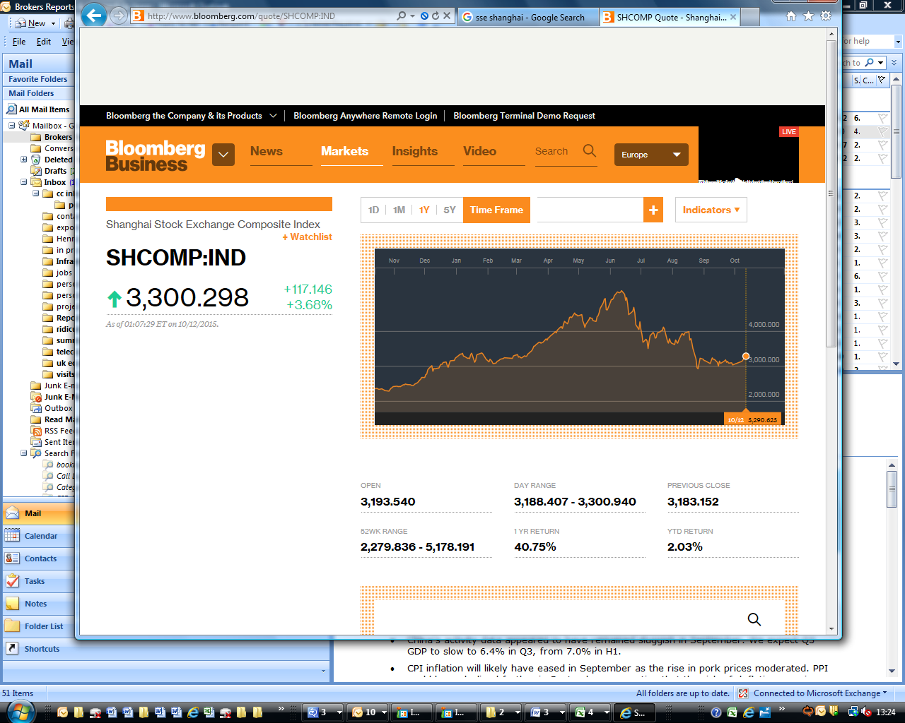**China’s Stock Market** is not a tail that wags the dog; it is not particularly influential on China’s economy (in fact, it bears almost zero correlation to GDP growth). It is however widely talked about and a good indicator of sentiment. If you invested money a year ago today, you’d have made 40.75%, or if you’d entered on 1st January, you’d be up 2%. Many smaller investors entered (with borrowed money) later than that – the market is 35% below the June peak. The good news is that September’s market was basically flat (down by “only”) 4.8%, giving hope that the Summer’s crash has at least paused, if not ended. The government needs another few quiet months like this in order to re-establish credibility, and calm – which are (we believe) preconditions to further reforms in the capital markets, including deepening international connections such as extending the HK-Shanghai connect.

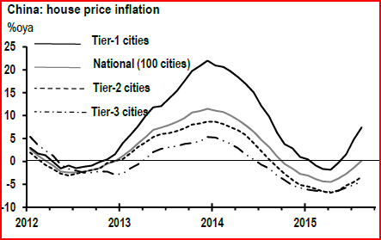

**Property** is the other asset class which people watch for signs of bubbles.Data is spotty, but the prices in large cities are rising again (1% in August)

for the first time since October 2014 (having dipped during the first quarter). The price falls continue in smaller cities – albeit at a slowing rate. Anecdotally, we hear that with property and stocks being the two largest investment classes, the poor stock market performance pushes speculative investment into housing. Seen from here, these house-price rises (at, or below wage increases) look to be in the safe zone, but (as in many countries) there is a lively debate about whether overall valuations are right. According to [international comparisons](http://www.numbeo.com/property-investment/rankings.jsp) of price to income ratios, Beijing is the world’s 6th most expensive city (and London 11th). The property market remains an area to watch as it hugely influential on China’s economy (because of the high percentage of new build property, the market in China is more strongly correlated with both investment and consumption than the UK’s market is).

**Real Economy –disappointing but not falling off a cliff**

The slowing economic outlook was reflected in number of data points:

* The China Manufacturing PMI stabilised in September (at 49.8) after falling to its weakest reading since the 2008 Global Financial Crisis in August (49.7).
* August Fixed Asset Investment (FAI) growth came in at 10.9% y-o-y, year to date, down from 11.2% in July
* The employment index fell to the weakest level since January 2009.

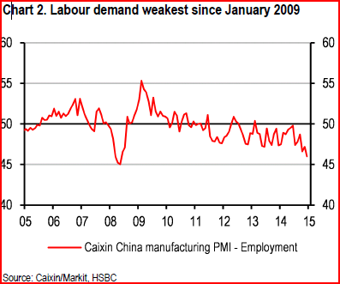Banks are adjusting downwards their growth forecasts accordingly – for instance ANZ expect Q3 GDP to slow to 6.4% in Q3, down from 7.0% in the first half of the year. The consensus seems to be for 2015 full year growth to come in at 6.8% - though this is somewhat fictitious (as we’ve reported elsewhere), most of our contacts believe the true figure to be something between 5-6%.

**Trade – China is no motor for global growth**



Exports and imports are still falling – in fact the fall in China’s imports worsened in August, a concerning trend, particularly as these falling imports go hand-in-hand with continued GDP growth. China’s trade surplus continues to be large. China is not providing much of a motor to global growth (something we looked at in detail in our note in August “Why Are China’s Imports Falling?”)

**Capital Account.** “*Does China Have Enough FX Reserves*?” was the provocative title of a very thoughtful [report by UBS this month](https://neo.ubs.com/shared/d1T0tR3BFlYN0M/) (their basic conclusion: yes).

China’s foreign exchange management has been pleasingly uneventful since the August 3% devaluation – many of our private sector contacts are still bruised by the way the PBOC handed that.

Chatter is now about capital outflows from China – and the falling FX reserves reflect the PBOC’s intervention to prop up the value of the currency. A big change against the backdrop of reserve buildup over the previous decade. BNP Paribas’ (attached) analysis of this looks right to us – the motivation behind the devaluation was to introduce greater currency flexibility, rather than outright devaluation, and should be seen as part of a longer-term plan to open up the capital account. China’s RMB overtook the Japanese Yen became the world’s 4th most transacted currency according to data from SWIFT this month.

**Comment**

* The summer storms have quietened. There is nothing to suggest that China is returning to its heyday of economic growth, but Xi Jinping and his team will be hoping for a few more calm months like September.
* It’s also worth noting that the authorities haven’t hit the panic button – yes there has been monetary policy easing and some limited fiscal stimulus, but nothing on the scale of the 2008 mega-stimulus (and they do have plenty of space to do so). This suggests that the leadership will be true to their word and accept the “New Normal”, and manage expectations accordingly.
* The 5 year (2016-2015) Economic Plan will be released shortly – we’ll be watching that carefully, as it provides the leadership an opportunity to signal whether they are courageous enough to set out a stall of further economic reform, or whether the jitters over the summer will have put the reformers onto the back foot.